|  |  |  |
| --- | --- | --- |
| 1. **DEBRE BERHAN UNIVERSITY** |  | **COLLEGE OF COMPUTING SCIENCE** |

**Fundamental of Machine Learning Group Assignment**

**Department: Software Engineering**

**Course Name: Fundamental of Machine Learning**

**Course Code: Seng9032**

**Name Id No**

**Habtemariam Kibru 1868/12**

**Hiro Worku 1400/12**

**Nahom Mesfin 1721/12**

Contents

Introduction 1

Our Motivation 1

Problem Statement 1

General Objective 2

Specific Objective 2

ME THODOLOGY 2

CONVOLUTIONAL NEURAL NETWORK (CNN) 2

Project Development Method 2

Data Source: 3

Data Pre-processing and Implementation 3

1. Import libraries 4

2. Load datasets 4

3. Split the data 4

4. Build Model 5

5. fit the model. 5

6. Create confusion Matrix 5

7. Test the model 6

Recommendations 8

CONCLUSION 8

# Introduction

Gender and age are central to our identity. It also plays an important role in our social lives. Gender and age recognition can be used in a variety of fields, including smart human-machine interface development, health, cosmetics, electronic commerce, and so on. Recognition of people's gender and age from facial images is an ongoing and active research problem. In the proposed solution, Convolutional Neural Network (CNN), is used as a feature extractor. CNN takes input images and assigns values to different objects in the image (learnable weights and biases) so that it can distinguish between them. CNN necessitates significantly less preprocessing than other classification algorithms. While the filters are made by hand using primitive techniques, CNN can learn these features with enough training. Face images of individuals were trained with coevolutionary neural networks in this study, and age and gender were successfully predicted. Over 20,000 images have age and gender annotations. The photos include a variety of poses, facial expressions, lighting, occlusion, and resolution.

## Our Motivation

Our motivation is from market perspective, our age and gender prediction project can be used in market research to help marketers better target their advertising campaigns. Using this project marketers will able to create more detailed audience profiles that increase the effectiveness of their advertisement. For example, they can determine the best platform or channels to use for promotions, discover which content works well with different age ranges or genders, and develop educated marketing strategies that focus on a specific demographic. Additionally, tracking the responses to various ad campaigns based on age and gender predictions can provide valuable insights into consumer motivation and behavior.

# Problem Statement

The problem statement of age and gender prediction in marketing is determining the most effective marketing strategies by targeting different genders and age groups. Marketers must understand and differentiate between the preferences, attitudes, abilities, and interests of various demographic groups in order to create strategic campaigns that will reach their desired market segments or target audience. Furthermore, marketers should be able to identify through predictive analytics how various products or services benefit different demographics in order to accurately engage each group with targeted messages. Understanding how to hone messaging towards different ages and genders can increase engagement rates leading to more conversions for a company’s products/services.

Age and gender prediction in the market is becoming increasingly difficult as customer demographics become more diverse and complex. While some businesses have implemented strategies to target their customers with personalized ads, promotions, and content; many businesses are left without a reliable way to accurately predict age and gender of their customers. Additionally, traditional demographic data such as age and gender are often inadequate to determine key insights into customers' interests and motivations.

We tried solving the above problems by using machine learning algorithms such as deep learning neural networks to predict age and gender of customers based on facial recognition technology. By collecting customer images during checkout events or other means of interaction such as online surveys, a predictive model can be developed that identifies the presence of any human face in an image, measures important features such as face size, shape & orientation, then uses them to make decisions about age and gender.

# General Objective

The goal of this work is to train and evaluate a given convolutional neural network to accomplish gender classification and age estimation on images.

# Specific Objective

The specific objective of this project is to develop accurate age and gender prediction algorithms for use in market demographic models to improve target audience segmentation and optimize advertising campaigns, Use in Health Center, Use in identity verification, Use in sport

# ME THODOLOGY

## CONVOLUTIONAL NEURAL NETWORK (CNN)

A CNN (convolutional neural network) is a kind of artificial neural network that is commonly used for image or object identification and categorization. Using a CNN, Deep Learning recognizes items in an image. An input layer, hidden layers, and an output layer are all part of a standard neural network. The anatomy of the brain inspired CNNs. Artificial neurons or nodes in CNNs collect inputs, process them, and deliver the result as output, rather like a neuron inside the brain functions and transmits signals between cells. The images are used as a source of data. Multiple hidden layers may exist in CNNs, each of which performs feature extraction from the image by performing calculations. The very first layer that extracts feature out of an input image is convolution. The object is classified and identified in the output layer by the fully connected layer. The convolutional layer is the most important constituent of CNN. The mathematical procedure of convolution is used to combine two sources of data.

Gender estimation from social image collection, images that do not require access to private details of the subject areas that are not displayed in the images, such as their birth date, and the usual approach that includes the collection of other information about an individual and on the basis about which we discover gender on manually handled annotated data for gender recognition. That is why we use D-CNN, which works directly on images and aids in precise gender estimation. Overfitting is usually a minor issue. Comes into play if deep learning or machine learning-based approaches are used on a dataset with such a small number of face images.

## Project Development Method

We use agile project development method in our project for its incremental approach when it comes to the development of a complex solution. It allows to focus on delivering value early, by creating tested and refined prototypes that are ready for market.

After we start this project we added different features like changing the dataset , First we were training the model by using csv file dataset but it was difficult to predict real-world images so we change the dataset to UTK jpg dataset from Kaggle.

We also add interface after the presentation because we want to make easy for the end user.

## Data Source:

The data source for this project comes from UTK Dataset.

The data collection consists of more than 20,000 facial images with age, gender and ethnicity annotations. The images cover a wide range of poses, facial expression, lighting, resolution. It used for a variety of tasks, for example face detection, age estimation, gender recognition etc. We need to split our dataset into three parts: training dataset, test dataset and validation dataset. The purpose of splitting data is to avoid overfitting which is paying attention to minor details/noise which is not necessary and only optimizes the training dataset accuracy. We need a model that performs well on a dataset that it has never seen (test data), which is called generalization. The training set is the actual subset of the dataset that we use to train the model. The model observes and learns from this data and then optimizes its parameters. The validation dataset is used to select hyperparameters (learning rate, regularization parameters). When the model is performing well enough on our validation dataset, we can stop learning using a training dataset. The test set is the remaining subset of data used to provide an unbiased evaluation of a final model fit on the training dataset.

**Description of some used Library**

* **NumPy:** NumPy is the most basic yet a powerful package for mathematical and scientific computing and data manipulation in python. It is an open-source library available in python.
* **Cv2**: OpenCV is a high-performance library for digital image processing and computer vision, which is free and open source.
* **Matplotlib:** Matplotlib is a plotting library for the python programming language and its numerical mathematics extensions in NumPy.
* **OS:** The OS module in python provides a way of using operating system dependent functionality
* **KERAS:** Karas is an open-source high-level neural network API, written in python. It allows easy and fast prototyping

**Technology**

**Image Processing:** Image processing is a method to perform some operations on an image, in order to get an enhanced image or to extract some useful information from it. It is a type of signal processing in which input is an image and output may be image or characteristics/features associated with that image.

**Computer Vision:** Computer vision is a field of artificial intelligence that trains computers to interpret and understand the visual world. Using digital images from cameras and videos and deep learning models, machines can accurately identify and classify objects.

# Data Pre-processing and Implementation

1. Grayscale conversion
2. Normalization

we normalize the data by converting the datatype of variable data to float32 and dividing it by 255.

1. Data Augmentation
2. Image standardization

* Before we start exploring preprocessing techniques, let’s first explore the RGB channels of our original image;

# Import libraries

# Load datasets

**Procedure**

Load dataset and get the list of all the files and directories in the specified path using os.listdir( ).

*#use the file path where your dataset is stored*

*path = "C:/Users/hm/Dropbox/My PC (LAPTOP-6M4OIP3C)/Desktop/PY/Image/crop_part1/"*

Using cv2.imread( ) we read an image from each file as an array

*images = []*

*age = []*

*gender = []*

*for img in os.listdir(path):*

*ages = img.split("_")[0]*

*genders = img.split("_")[1]*

*img = cv2.imread(str(path)+"/"+str(img))*

*img = cv2.cvtColor(img,cv2.COLOR_BGR2RGB)*

*images.append(np.array(img))*

*age.append(np.array(ages))*

*gender.append(np.array(genders))*

Next we normalize the data by converting the datatype of variable data to float32 and dividing it by 255.

*#data values are normalized*

*age = np.array(age,dtype=np.int64)*

*images = np.array(images)*

*Gender=np.array(gender,np.uint64)*

# Split the data

As discussed last time, the data needs to be split into two different sets:

* Training set: the algorithm will read, or ‘train’, on this over and over again to try and learn its task.
* Testing set: the algorithm is tested on this data to see how well it works.

*x_train_age, x_test_age, y_train_age, y_test_age = train_test_split(images, age, random_state=42)*

*x_train_gender, x_test_gender, y_train_gender, y_test_gender = train_test_split(images, gender, random_state=42)*

# Build Model

**There are two ways to build keras models :** sequential and functional. In our project we are using sequential by which we create a model layer-by-layer.

When we use Conv2D as the first layer we must define the input shape. This layer creates a convolution kernel that is convolved with the layer input to produce a tensor of outputs.

Activation is used for “relu”

The MaxPooling2D layer is used for spatial data.

Dropout layer is used to prevent a model from overfitting.

Dense layer is a linear operation in which every input is connected to every output by a weight.

agemodel = Sequential()

agemodel.add(Conv2D(32, (3,3), activation='relu', input_shape=(200, 200, 3)))

agemodel.add(MaxPooling2D((2,2)))

agemodel.add(Conv2D(64, (3,3), activation='relu'))

agemodel.add(MaxPooling2D((2,2)))

agemodel.add(Conv2D(128, (3,3), activation='relu'))

agemodel.add(MaxPooling2D((2,2)))

agemodel.add(Flatten())

agemodel.add(Dense(64, activation='relu'))

agemodel.add(Dropout(0.5))

agemodel.add(Dense(1, activation='relu'))

agemodel.compile(loss='mean_squared_error',

optimizer=optimizers.Adam(lr=0.0001))

genmodel = Sequential()

genmodel.add(Conv2D(32, (3,3), activation='relu', input_shape=(200, 200, 3)))

genmodel.add(MaxPooling2D((2,2)))

genmodel.add(Conv2D(64, (3,3), activation='relu'))

genmodel.add(MaxPooling2D((2,2)))

genmodel.add(Conv2D(128, (3,3), activation='relu'))

genmodel.add(MaxPooling2D((2,2)))

genmodel.add(Flatten())

genmodel.add(Dense(64, activation='relu'))

genmodel.add(Dropout(0.5))

genmodel.add(Dense(1, activation='sigmoid'))

genmodel.compile(loss='binary_crossentropy',

optimizer=optimizers.Adam(lr=0.0001),

metrics=['accuracy'])

# fit the model.

# Create confusion Matrix

*#Age Confusion Matrix - verify accuracy of each class*

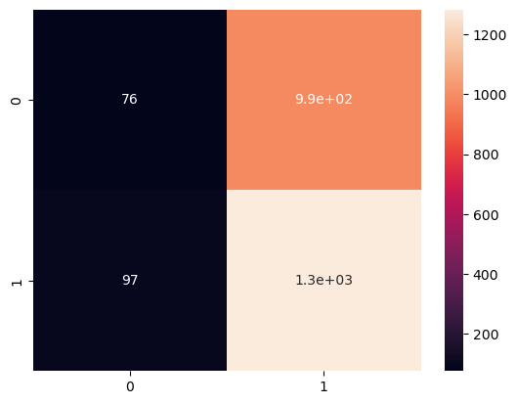

Accuracy = 0.5558282208588957

#Gender Confusion Matrix - verify accuracy of each class

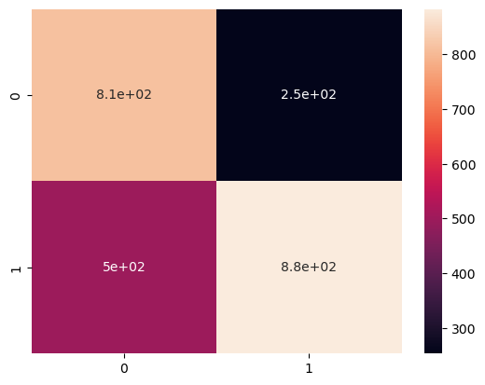

Accuracy = 0.6932515337423313

# Test the model

## Input image from user to test the model

*Example*

*process_and_predict('C:/Users/hm/Dropbox/My PC (LAPTOP-6M4OIP3C)/Pictures/WIN_20220524_13_31_21_Pro.jpg')*

Age: 26

Gender: male



## Real time Gender and Age Recognition by using webcam

**Steps to follow:**

1. Face detection with Haarcascade
2. Gender Recognition with CNN

**1. Face detection with Haarcascades:**

This is a part most of us at least have heard of. OpenCV provide direct methods to import Haarcascades and use them to detect faces.

**2. Gender and Age Recognition with CNN :**

CNN algorithm is used for Gender and age recognition. The CNN’s output layer (probability layer) in this CNN consists of two classes ‘Male’ or ‘Female’ and age .

*Example*  
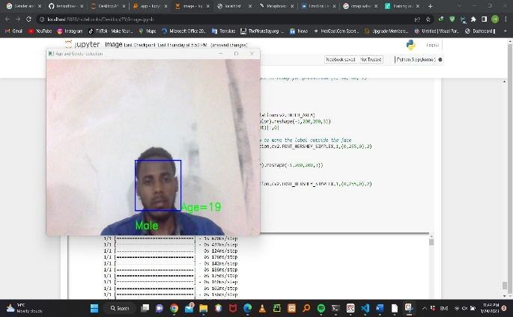

## We Add Interface by using tkinter library

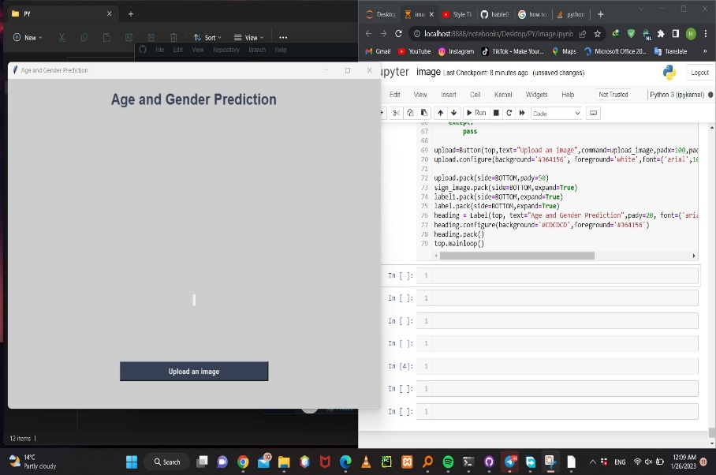

When we run the **tkinter** code we get the above interface it allows us to upload image

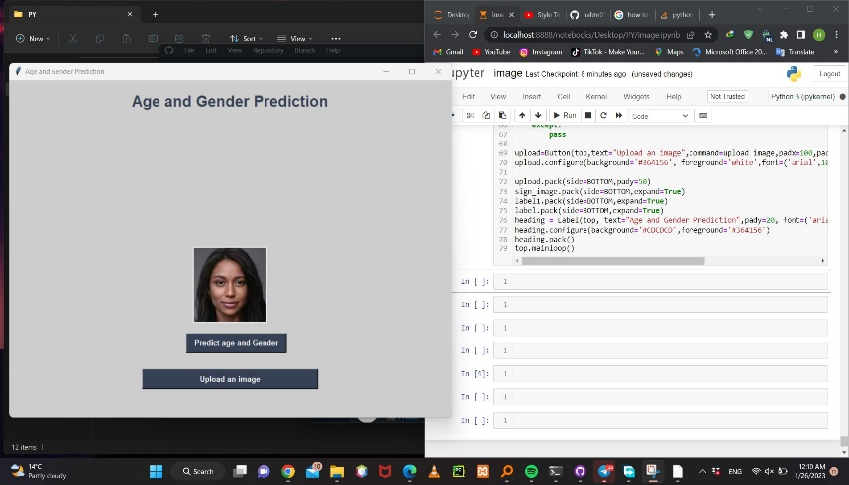

When we upload image we will get the prediction button

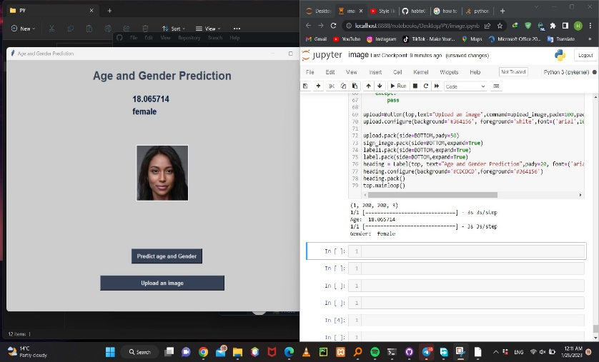

**Finally we will get the predicted age and gender above from the uploaded image**

# Recommendations

Age and gender prediction in the market used to be a difficult task, but with the advent of modern technology it's become much easier. The most popular approach to age and gender prediction is through machine learning algorithms. By setting up specific tracking campaigns it’s possible to determine where people are likely to be within different age or gender groupings based on their behaviors or purchasing habits. Once the algorithms have been trained on the targeted data set its ready for deployment. This strategy works best if users provide accurate feedback about their age and gender which should improve accuracy over time. However, care should be taken not to make assumptions from limited inputs such as photos since they may not be an accurate representation of age/gender demographics associated with each account holder. Overall using machine learning algorithms can prove beneficial when trying to accurately predict age/gender demographics of a market. With the right kind of collections, analysis and deployment decisions can be made with greater confidence knowing that customers have been segmented into more finely tuned subgroups that allow for more effective targeting strategies leading to better outcomes overall.

# CONCLUSION

we proposed a model to Classify the gender by feeding the CNN image dataset, a deep learning algorithm and trained in broad database face-recognition. In all, we think that the accuracy of the model is decent. but can be further improved by using more data, data increase and better network architecture.

From this Project, we can conclude with two important conclusions. First, despite the limited availability of age and gender-tagged photos, CNN can be used to improve age and gender detection outcomes. Second, by employing additional training data and more complex systems, the system's performance can be slightly increased. With the right kind of collections, analysis and deployment decisions can be made with greater confidence knowing that customers have been segmented into more finely tuned subgroups that allow for more effective targeting strategies leading to better outcomes overall.